Part Number: PU060 – 47111 – P1

PU060 – 47111 – F1

PU060 – 47111 – R1 PU060 – 47115 – P1

PU060 – 47115 – F1

PU060 – 47115 – R1

Kit Contents
Item # | Quantity Reqd. | Description
1 | 1 | Front Passenger Side Mudguard
2 | 1 | Front Driver Side Mudguard
3 | 1 | Rear Passenger Side Mudguard
4 | 1 | Rear Driver Side Mudguard
5 | 1 | Hardware Kit
6 | 1 | Instruction Sheet (Electronic Copy)
Hardware Bag Contents
Item # | Quantity Reqd. | Description
1 | 4 | M5 x 20 mm Screws
2 | 4 | M5 x 15mm Screws
3 | 2 | M5 Spring Clips (Large)
4 | 2 | M5 Spring Clips (Narrow)
5 | 4 | M5 Spring Clips (Medium)
6 | 4 | Push Pins
Additional Items Required For Installation
Item # | Quantity Reqd. | Description
1
Conflicts
Ground effects
Recommended Tools
Personal & Vehicle Protection | Notes
None
Special Tools | Notes
Installation Tools | Notes
Screwdriver | Phillips #2 & #3
Screwdriver | Slot
Socket/Driver | 10mm (3/8”)
Drill
Drill Bit | 6mm (1/4”), 8mm (5/16”)
Clean Cloth/Rag
Special Chemicals | Notes
Cleaner | VDC Approved Cleaner or Soap & Water Mixture
General Applicability
Models Without Rear Lower Spoiler
PU060-4711-P1 PU060-4711-AU
PU060-4711-F1 PU060-4711-AF
PU060-4711-R1 PU060-4711-AR

Models With Rear Lower Spoiler
PU060-47115-P1 PU060-47115-EP
PU060-47115-F1 PU060-47115-EF
PU060-47115-R1 PU060-47115-ER

PU060-47115-AP
PU060-47115-AF
PU060-47115-AR
Recommended Sequence of Application
Item # | Accessory
1
2
3
*Mandatory
Vehicle Service Parts (may be required for reassembly)
Item # | Quantity Reqd. | Description
1
2
3
Legend
STOP: Damage to the vehicle may occur. Do not proceed until process has been complied with.
OPERATOR SAFETY: Use caution to avoid risk of injury.
CAUTION: A process that must be carefully observed in order to reduce the risk of damage to the accessory/vehicle and to ensure a quality installation.
TOOLS & EQUIPMENT: Used in Figures calls out the specific tools and equipment recommended for this process.
REVISION MARK: This mark highlights a change in installation with respect to previous issue.
SAFETY TORQUE: This mark indicates that torque is related to safety.

Care must be taken when installing this accessory to ensure damage does not occur to the vehicle. The installation of this accessory should follow approved guidelines to ensure a quality installation.

These guidelines can be found in the "Accessory Installation Practices" document.

This document covers such items as:-
- Vehicle Protection (use of covers and blankets, cleaning chemicals, etc.).
- Safety (eye protection, rechecking torque procedure, etc.).
- Vehicle Disassembly/Reassembly (panel removal, part storage, etc.).
- Electrical Component Disassembly/Reassembly (battery disconnection, connector removal, etc.).

Please see your Toyota dealer for a copy of this document.

Prepare to Mount the Front Mudguards.
  - Clean and degrease the front body panel where the mudguard will be located with a clean cloth and VDC approved cleaner or soap/water mixture.
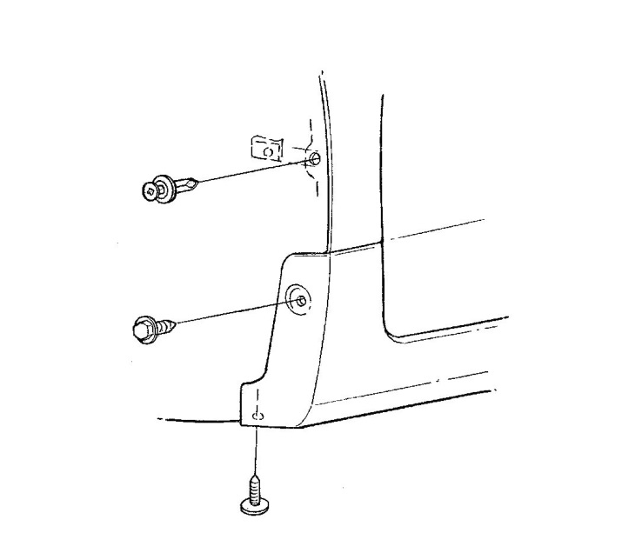
  - Remove the existing screws at locations B and D (Fig. 1-1). Do not discard them.
Fig. 1-1
10mm socket & driver, #2 Philips screwdriver and slot screwdriver

D
A
Existing
Push Pin
(Discard)
Existing
Screw
B
Supplied
Spring Clip
(Narrow)
Existing Screw
  - Remove and discard the existing push pin at location A (Fig. 1-1).
  - Pull the liner forward and install a supplied spring clip (narrow) centered over location A with the turned up edge on the inside of the panel (Fig. 1-1).

Install the Front Mudguards.
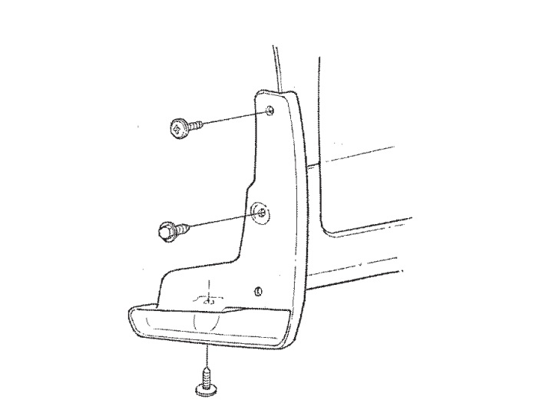
  - Hold the part up and into the body and reinstall the factory screws in location D, then B (Fig. 2-1).
Fig. 2-1
10mm socket & driver, #2 Philips screwdriver and slot screwdriver

Mudguard
A
Supplied
20mm Screw
Existing
Screw
B
Existing Screw
C
D
  - Hold the part tight against the body and install a supplied 20mm screw in location A (Fig. 2-1).

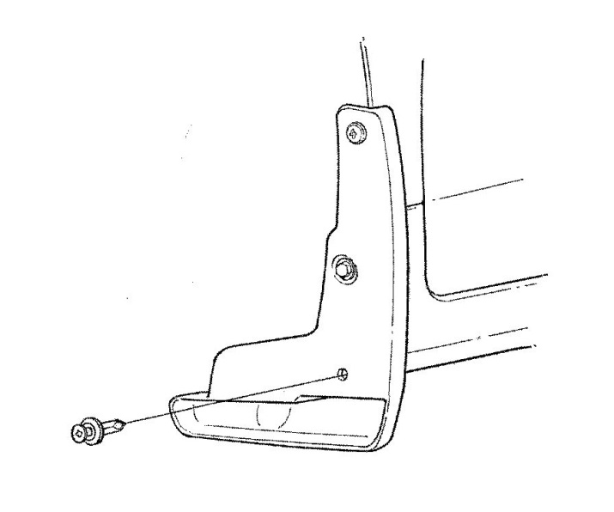
  - Hold the part in position and drill an 8mm (5/16”) hole in location C (Fig. 2-2).
Fig. 2-2
8mm (5/16”) drill bit & drill
Supplied
Push Pin
C
  - Hold the part into the body and install a supplied push pin in location C (Fig. 2-2).
  - Repeat Steps 1 and 2 on the other side.

Prepare to Mount the Rear Mudguards.
NOTE: Removal and reinstallation of THE rear WHeelS is required to drill the attachment holes.
  - Clean and degrease the rear bumper panel where the mudguard will be located with a clean cloth and VDC approved cleaner or soap/water mixture.
NOTE: The following instructions are for both vehicles with and without a rear lower spoiler.
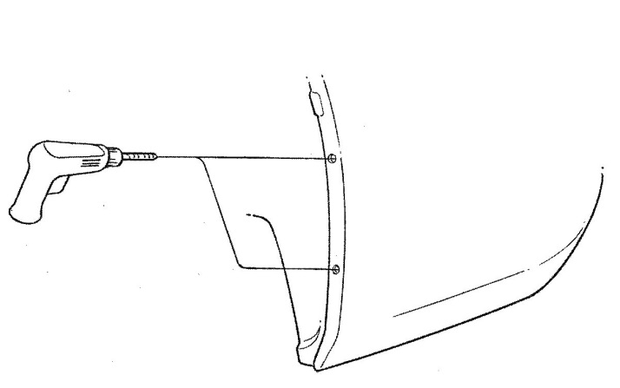
  - Identify the existing dimples at hole locations A and B (Fig. 3-1).
Fig. 3-1
6mm (1/4”) drill bit & drill
6mm Drill Bit
B (dimple)
A (dimple)
Drill
  - Drill 6mm (1/4”) holes at locations A and B (Fig. 3-1). Make sure to drill through both the panel and the liner.

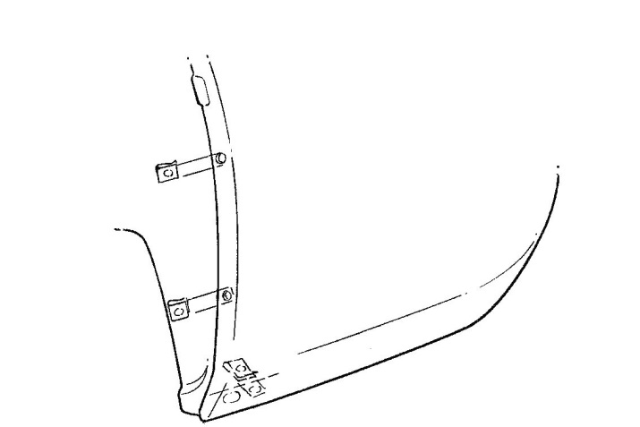
  - Install a supplied spring clip (medium) over the panel edge holes at locations A and B with the turned-up edge on the inside of panel (Fig. 3-2).
Fig. 3-2
Supplied Spring Clip (Large)
B
A
Supplied Spring Clips (Medium)

  - Identify the existing lower mount hole at location C and install a supplied (large) spring clip (Fig. 3-2). Center the clip over the hole with the turned up edge on the inside of the panel.

Install the Rear Mudguards.
  - Mount the rear mudguard, and if the vehicle is equiped with a spoiler, ensure it is positioned in the slot.
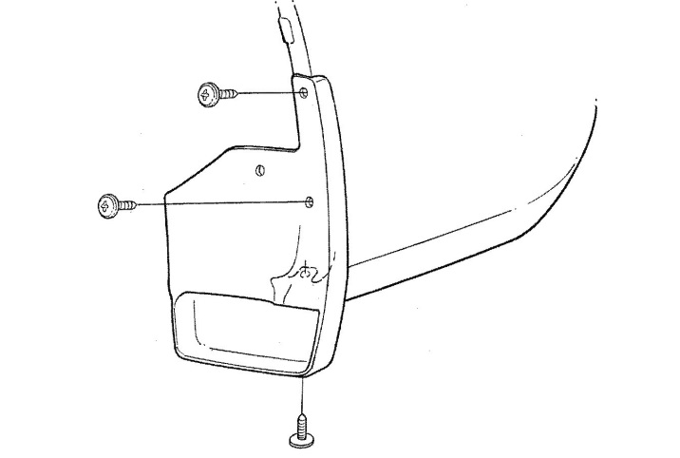
  - Hold the part up and into the bumper panel and install a supplied 20mm screw in location C (Fig. 4-1).
Fig. 4-1
#2 Phillips Screwdriver
Supplied
#20mm Screw
Mudguard

A
B
C
Supplied
15mm Screw
  - Hold the part tightly up and against the bumper inner panel and install a supplied 15mm screw in locations A and B (Fig. 4-1).

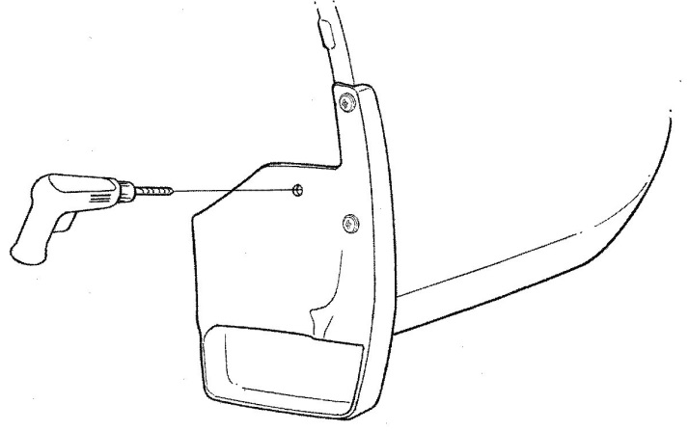
  - Hold the part in position and drill an 8mm (5/16”) hole in location C (Fig. 4-2).
Fig. 4-2
8mm (5/16”) drill bit & drill
8mm Drill Bit
D
Drill

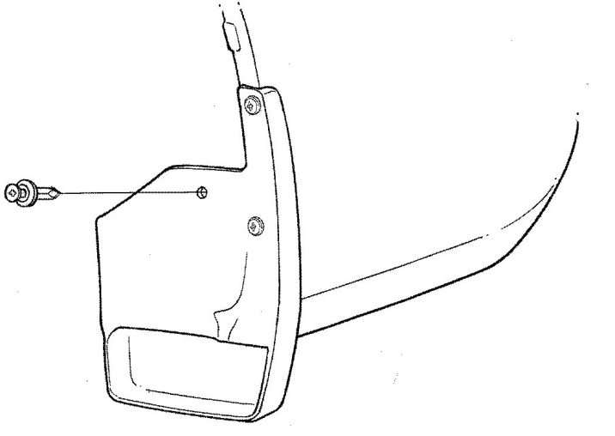
  - Hold the part into the bumper inner panel and install a supplied push pin into location C (Fig. 4-3).
Fig. 4-3
Supplied
Push Pin
D
  - Repeat Steps 3 and 4 on the other side.

Accessory Function Checks
Gaps between mudguards and body side

Vehicle Function Checks

Excessive gaps greater than 1.0 mm

Vehicle Appearance Check
After accessory installation and removal of protective cover(s), perform a visual inspection.

Ensure no damage (including scuffs and scratches) was caused during the installation process.
(For PPO installations, refer to TMS Accessory Quality Shipping Standard.)

